331219 | Water Utility Distribution – Fire Hydrants

- FIRE HYDRANT REQUIREMENTS

NOTE: All University of Kentucky Fire Hydrants are classified as

“Privately Owned”

It is the policy of the University of Kentucky that all fire hydrants located on the Lexington Campus shall meet the following minimum specifications.

1.1. All fire hydrants must comply with the Kentucky American Water Company fire hydrant specification - traffic model.

1.2. All fire department connections shall be within 50 feet of a hydrant (Lexington area).

1.3. Only national standard threads are acceptable.

1.4. Each hydrant must have a gate valve and valve box.

1.5. Specifications:

Minimum Water Main Size 8 inch
Minimum Dead End Main 8 inch
Hydrant Type Dry Barrel
Direction of Opening Right (clockwise)
New Hydrants (2) 4 ½” Openings
Existing Hydrants Min. of (1) 4 ½” Opening
Depth of Bury 3’-6” Minimum
Main Valve Opening 5 ¼” Minimum
Type of Inlet 6 inch
Type of Caps 15/16” inch square nut with chains
Operating Nut Size 15/16-inch square
Center of Outlets to Ground 18 inches
1.6. All hydrants shall be painted with red barrels. The caps shall be painted per the “Classification of Hydrants” below:

Classification of Hydrants:
Class AA – Rated capacity of 1500 gpm or greater Light blue bonnet and caps
Class A – Rated capacity of 1000-1499 gpm Green bonnet and caps
Class B – Rated capacity of 500-999 gpm Orange bonnet and caps
Class C – Rated capacity of less than 500 gpm Red bonnet and caps

1.7. Where fire hydrants are installed along a roadway, parking within 15 feet is prohibited. All curbs within 15 feet of a hydrant shall be painted fire lane red.

1.8. When fire hydrants are installed in parking areas, parking shall be designed and maintained to allow 10 feet clear access to the hose connection side of the hydrant, and a four foot minimum clear radius around the hydrant

2. FIRE DEPARTMENT CONNECTION

2.1. Fire Department connections and the post indicator valves are to be painted red and clearly marked as to the building served with a permanent metal sign attached. The signs shall be constructed as follows:

2.1.1 Signs shall be made from 16” wide x 10” tall 0.0624” thick aluminum plate.
2.1.2 Plate shall be painted RED.
2.1.3 Plate shall have a 0.01875” WHITE reflective border offset 0.250” from the edges of the plate.
2.1.4 Sign Lettering shall be Highway Gothic font, 4” tall “F D C” using all capital letters and 1” tall (Street Address) and (System Type) in Upper first letter of each word.
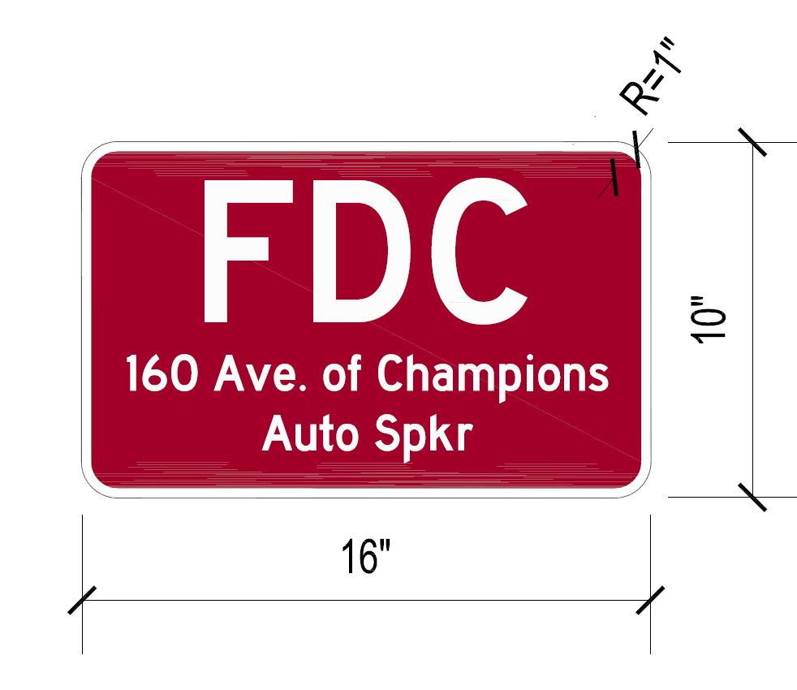

2.1.5 Signs shall be mounted on the pipe with two, adjustable stainless-steel airplane clamps at the top and bottom. Wall mounted signs shall be secured to the building wall with two 3/8” stainless steel expansion anchors.
2.1.6 Should there be two (2) fire department connections for a particular building, each fire department connection shall be identified as to the areas of the building it serves and identified as being a “wet” or “dry” connection.

2.2. All post indicator valves (PIV's) shall be equipped with provisions to mount an internal electric switch and shall have an internal conduit (1/2" min.) from this switch mounting location to the base of the post for connection of status monitoring equipment provided by the Fire Alarm System installer. Switch shall be covered with a splash proof cover and wiring and switch must be accessible without removal of any part of the PIV. Conduit shall have provision at base of post to exit immediately above grade and directly under the post. Conduit connections to the post shall be 1/2" NPT or larger.

3. OUTSIDE OF THE LEXINGTON AREA:

Meet the requirements of the local water company and local fire authority.

This document has been reformatted to meet current ADA digital accessibility requirements. No changes have been made to the technical content from the previously posted version.

REVISION DATE | PAGES | REMARKS
04/2026 | ALL | Verified document meets ADA Digital Accessibility Requirements

