- SCOPE AND SUMMARY

The National Electric Code requires analysis of new and renovated electrical systems. This specification clarifies how the analysis shall be performed and documented and standardizes the arc flash label appearance.

The analysis and labeling shall be the responsibility of the contractor for all new construction and for renovations including the addition or replacement of a transformer, substation, switchboard, transfer switch, generator, large distribution panel, motor control center, lighting panel or disconnect.

A professional engineer shall provide electrical power system studies for the project using the latest version of one of the following software packages: SKM PowerTools, EasyPower or etap. The software model files shall be submitted with the report. The analysis shall follow the latest IEEE 1584guidelines. An example report will be provided by the university upon request.

The analysis shall be submitted to the engineer of record prior to receiving final approval of the distribution equipment shop drawings and/or prior to release of equipment drawings for manufacturing.

- DATA AND DATA COLLECTION
Data shall be obtained for the power sources (campus 12 kV system and generators), impedance components (transformers, cables and busway), overcurrent protective devices (fuses, circuit breakers and relays) and other relevant equipment such as automatic transfer switches. Cable data (length, quantity per phase, size and type) shall be provided by the electrical contractor. Assumptions should only be used when the actual data is not available and the assumptions should be clearly listed in the report. Assumptions shall be kept to a minimum.

Where appropriate, the analysis shall use the following data for the starting point of the analysis at 12,470 V.
 | Short Circuit Analysis  and  Arc Flash - High Scenario |  | Arc Flash - Low Scenario
 | Contribution (A) | X/R | Contribution (A) | X/R
Three Phase | 11,855 | 14.4 | 5,920 | 17.1
Line to Ground | 11,983 | 16.4 | 6,004 | 18.3

- ONE LINE DIAGRAM
3.1 A one line diagram shall be provided as part of the analysis and shall clearly identify individual equipment buses, bus numbers used in the analysis, cable information (length, quantity per phase, size and type), overcurrent device information (manufacturer, type and size), transformers, motors, transfer switches, generators, etc.
3.2 The one line and analysis shall use a numbering scheme where each bus begins with a three digit number followed by a description (e.g., 102 MDPA or 103 ELEV DISC) and each connected circuit breaker or fuse shall have a corresponding designation (e.g., 102-1 MAIN CB, 102-2 ELEVATOR FDR or 103-1 ELEV DISC CB). An example one line will be provided by the university upon request.

- SHORT CIRCUIT ANALYSIS
4.1 A table shall be included which lists the calculated short-circuit currents (rms symmetrical three phase), equipment short-circuit interrupting or withstand current ratings, and notes regarding the adequacy or inadequacy of the equipment at each bus.
4.2 Any inadequacies shall be called to the attention of the engineer of record and recommendations made for improvements as soon as they are identified.

- PROTECTIVE DEVICE TIME-CURRENT COORDINATION ANALYSIS
5.1 A table shall be included which lists the recommended settings of each circuit breaker and relay.
5.2 A sufficient number of log-log plots shall be provided to indicate the degree of system protection and coordination by displaying the time-current characteristics of series connected overcurrent devices and other pertinent system parameters.
5.3 Deficiencies in protection and/or coordination shall be called to the attention of the engineer of record and recommendations made for improvements as soon as they are identified.
5.4 The electrical contractor shall be responsible to set the circuit breakers according to the analysis once the report has been approved by the engineer of record.

- ARC FLASH HAZARD ANALYSIS
6.1 The analysis shall be performed in compliance with the latest versions of NFPA 70E and IEEE Standard 1584.
6.2 The analysis shall consider multiple possible utility scenarios as shown above in section 2 as well as multiple system configurations where appropriate such as normal and emergency transfer switch positions and different main-tie-main configurations.
6.3 The Arc Flash Hazard Analysis shall include recommendations for reducing Arc Flash Incident Energy (AFIE) levels and enhancing worker safety.
6.4 Results of the Arc Flash Hazard Analysis shall be submitted in tabular form and shall include the following information for each bus location: bus name, protective device name, bus voltage, bolted fault, arcing fault, trip/delay time, equipment type, working distance, arc flash boundary, incident energy and protective clothing category.
6.5 Arc flash labels shall be supplied and installed. The labels shall include the AFIE, arc flash boundary, working distance, PPE category, PPE clothing description, PPE equipment description, voltage, glove class, shock protection boundaries according to NFPA 70E, analysis date, building number, equipment name and the upstream tripping device. The labels shall be 4 inches high by 6 inches wide and printed on a label of type THTEL-25-483-1-WA or similar. The arc flash label shall be formatted similarly to the examples shown below (Figure 1) and include the wording indicated in the table (Table 1) for each PPE category.

Figure 1. Example arc flash labels.
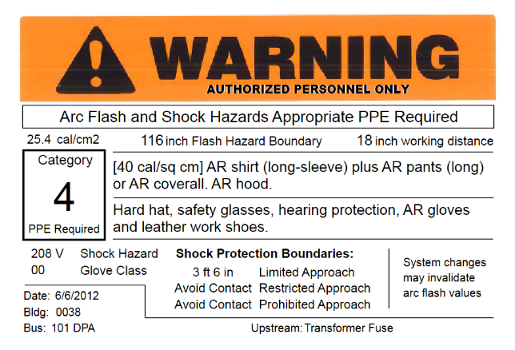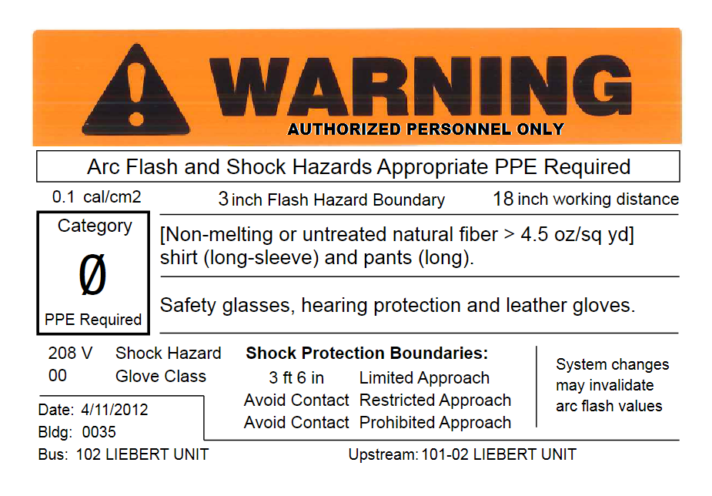

Table 1. Wording for the PPE related arc flash label fields.
Incident Energy (calories/cm²) | PPE Category | PPE clothing | PPE equipment
0  - 1.2 | 0 | [Non-melting or untreated natural fiber > 4.5 oz/sq yd] shirt (long-sleeve) and pants (long). | Safety glasses, hearing protection and leather gloves.
greater than 1.2  - 4 | 1 | [4 cal/sq cm] AR shirt (long-sleeve) plus AR  pants (long) or AR coverall. AR faceshield. | Hard hat, safety glasses, hearing protection, leather gloves and leather work shoes.
greater than 4  - 8 | 2 | [8 cal/sq cm] AR shirt (long-sleeve) plus AR pants (long) or AR coverall. AR balaclava and AR face shield or AR hood. | Hard hat, safety glasses, hearing protection, leather gloves and leather work shoes.
greater than 8  - 25 | 3 | [20 cal/sq cm] AR shirt (long-sleeve) plus AR  pants (long) or AR coverall. AR hood. | Hard hat, safety glasses, hearing protection, AR gloves and leather work shoes.
greater than 25  - 40 | 4 | [40 cal/sq cm] AR shirt (long-sleeve) plus AR  pants (long) or AR coverall. AR hood. | Hard hat, safety glasses, hearing protection, AR gloves and leather work shoes.
greater than 40 | X | Arc Flash Energy Exceeds the Rating of Category 4 PPE | Do not work on energized equipment

This document has been reformatted to meet current ADA digital accessibility requirements. No changes have been made to the technical content from the previously posted version.

REVISION DATE | PAGES | REMARKS
04/2026 | ALL | Verified document meets ADA Digital Accessibility Requirements

