23 0500 COMMON WORK RESULTS FOR HVAC, REFRIGERANT MANAGEMENT
Part 1 GENERAL INFORMATION AND PURPOSE
  - UNIVERSITY OF KENTUCKY REFRIGERANT MANAGEMENT PLAN (RMP)
- The purpose of the University of Kentucky’s Refrigerant Management Plan (RMP) is to establish the institutional framework necessary for the University to comply with Title VI of the Clean Air Act (CAA), Stratospheric Ozone Protection. The U.S. Environmental Protection Agency (EPA) developed specific regulations contained in 40 CFR 82, Protection of Stratospheric Ozone, and 40 CFR 84, Phasedown of Hydrofluorocarbons, to comply with the CAA. Although there are multiple subparts to these regulations, the University is subject to 40 CFR 82, Subpart B, Servicing of Motor Vehicle Air Conditioners; 40 CFR 82, Subpart F, Recycling and Emissions Reduction; 40 CFR 82, Subpart H, Halon Emissions Reduction; 40 CFR 84, Subpart B, Restrictions on the Use of Hydrofluorocarbons; and 40 CFR 84, Subpart C, Management of Regulated Substances. These regulations establish requirements for the service, maintenance, repair, and disposal of appliances containing ozone depleting substances (ODS) or non-ODS substances used as refrigerants.
- Appliances that contain refrigerants throughout the University include air conditioners, refrigerators/freezers, HVAC, chilled water fountains, chillers, motor vehicles, and in the case of halons and hydrofluorocarbons, fire and explosion protection equipment. The University requires all employees, contractors, or vendors that handle, order, service, maintain, repair, or dispose of refrigerants, refrigerant appliances, or halons to comply with this program.

Part 2 REQUIREMENTS
    - Ensure refrigerants are not knowingly released or disposed of during installation, maintenance, service, repair, disposal, or recovery.
    - Ensure only certified technicians are used for work that is reasonably expected to violate the integrity of the refrigerant circuit.
    - Provide Environmental Quality Management Department, Air Quality Compliance Specialist (AQCS), with copies of technician’s certifications that conducted installation, maintenance, or removal of appliances.
    - Complete and submit form AQ-FORM-101 to the AQCS when installing refrigerant appliances, other than small appliances.
    - Complete and submit form AQ-FORM-201 to the AQCS when conducting maintenance/service/repair on appliances containing 50 pounds or more of class I, class II, or a blend of class I and class II refrigerant per circuit OR 15 pounds or more of an HFC, a blend containing an HFC, or a substitute with a GWP greater than 53.
    - Complete and submit form AQ-FORM-401 to the AQCS when disposing of appliances with more than 5 pounds of refrigerant per circuit OR for the disposal of disposable HFC cylinders.
Part 3 FORMS
- AQ-FORM-101, Installation of Refrigerant-Containing Appliances (pg. 2)
- AQ-FORM-201, Maintenance of Refrigerant-Containing Appliances (pg. 4-6)
- AQ-FORM-401, Disposal of Refrigerant-Containing Appliances/HFC Cylinders (pg. 11-12)

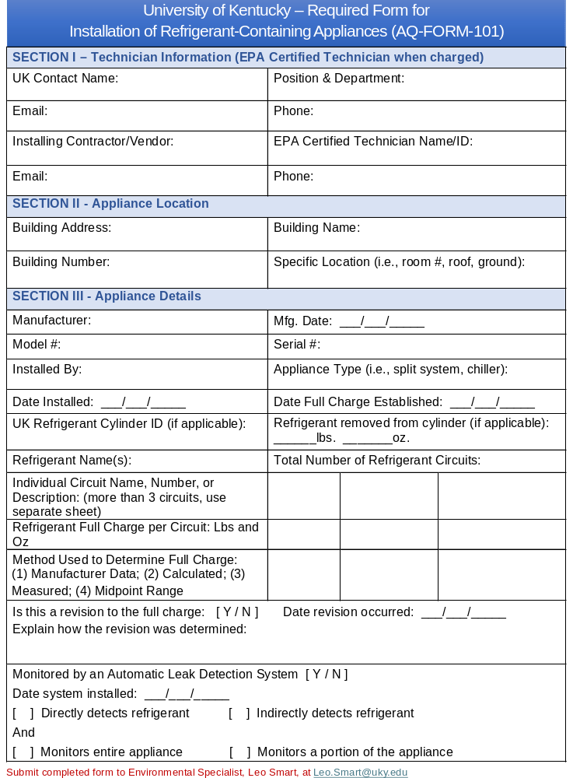
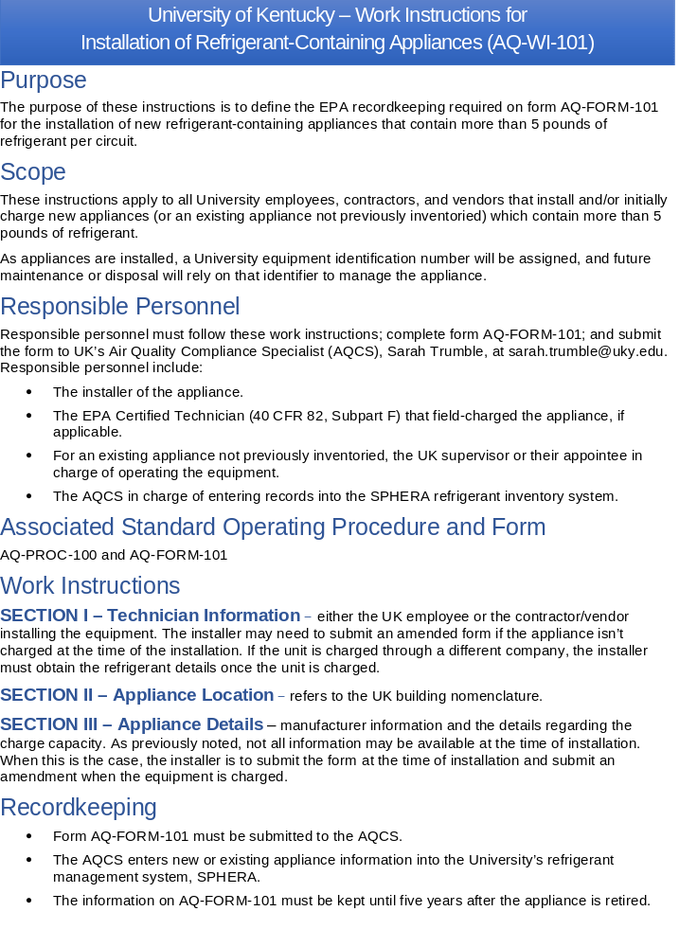
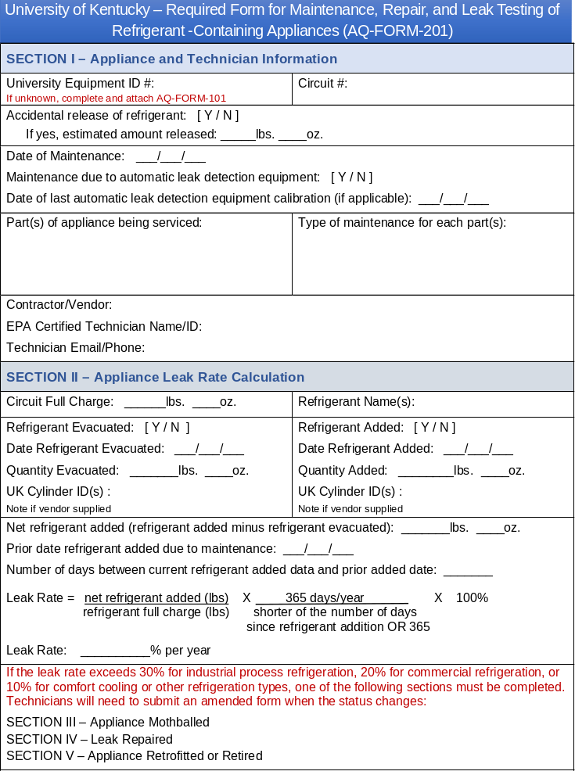
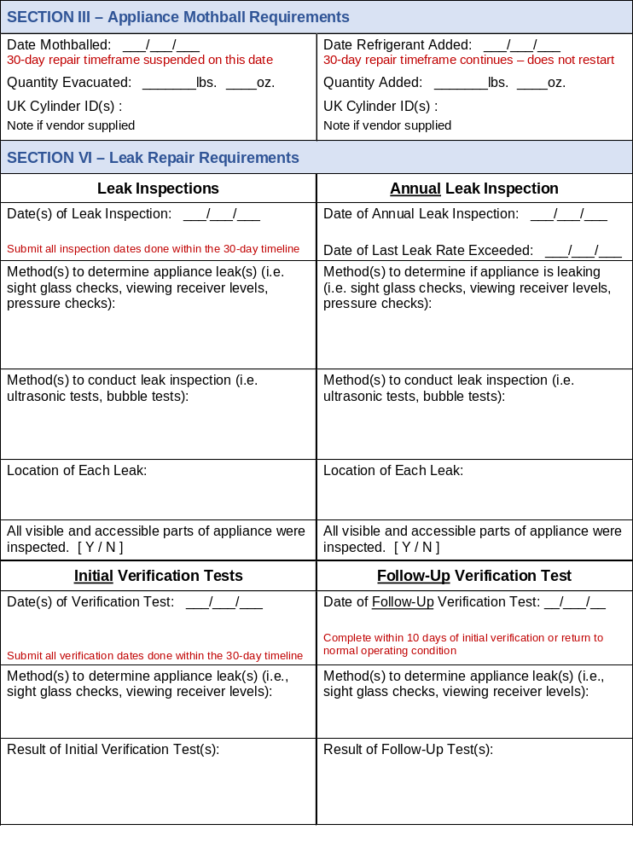
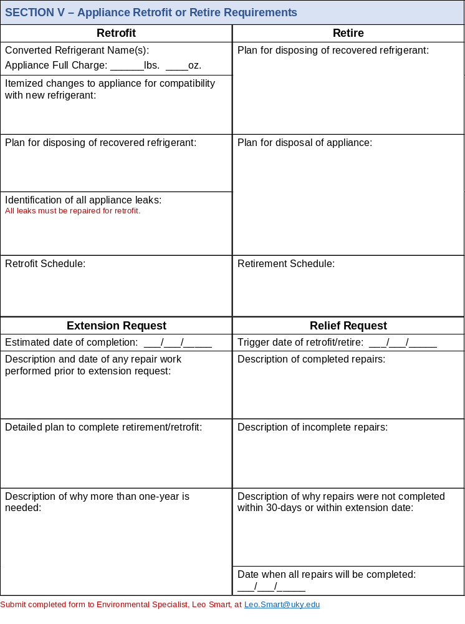
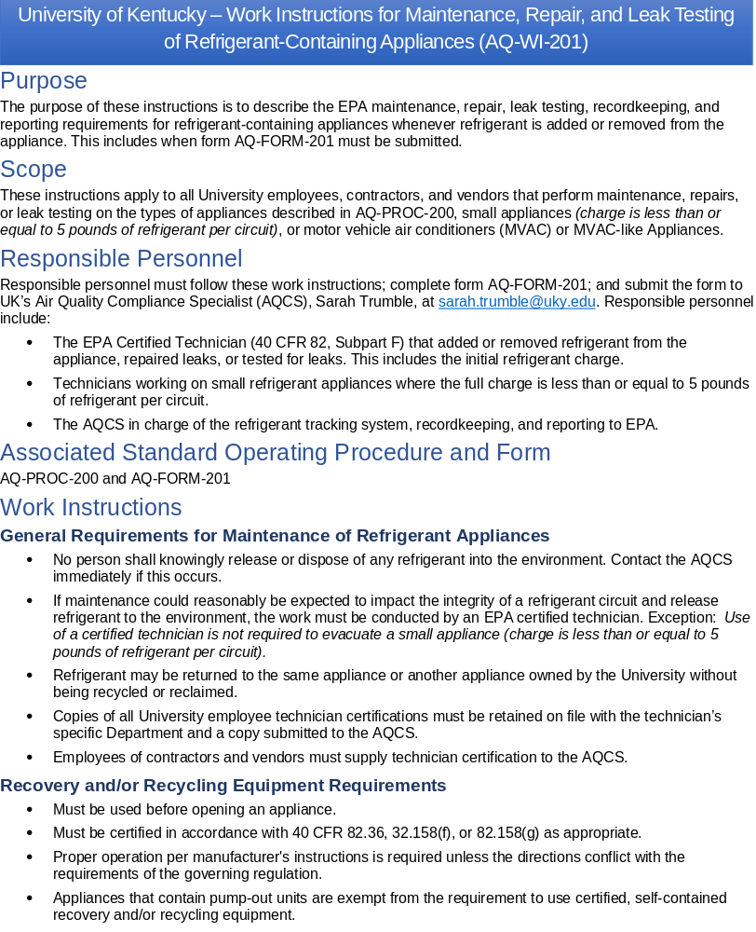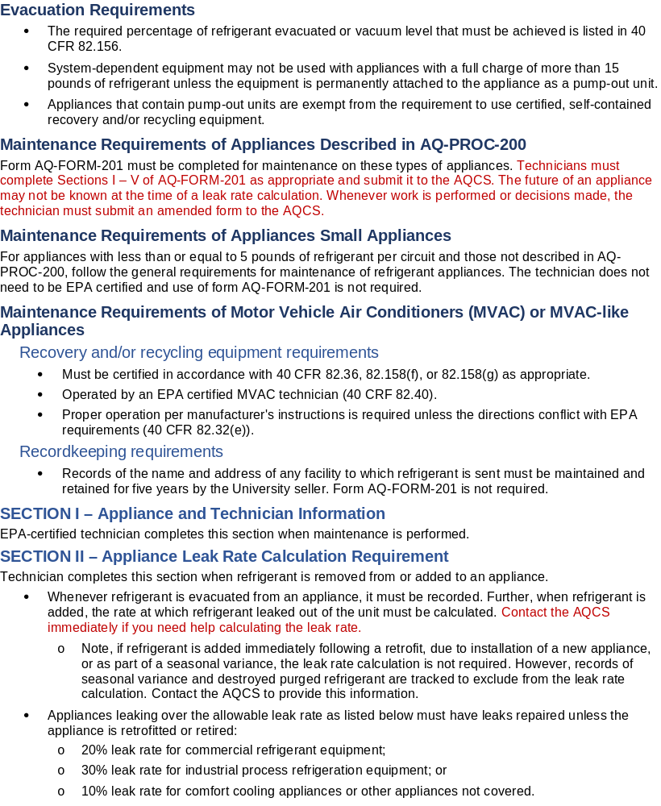
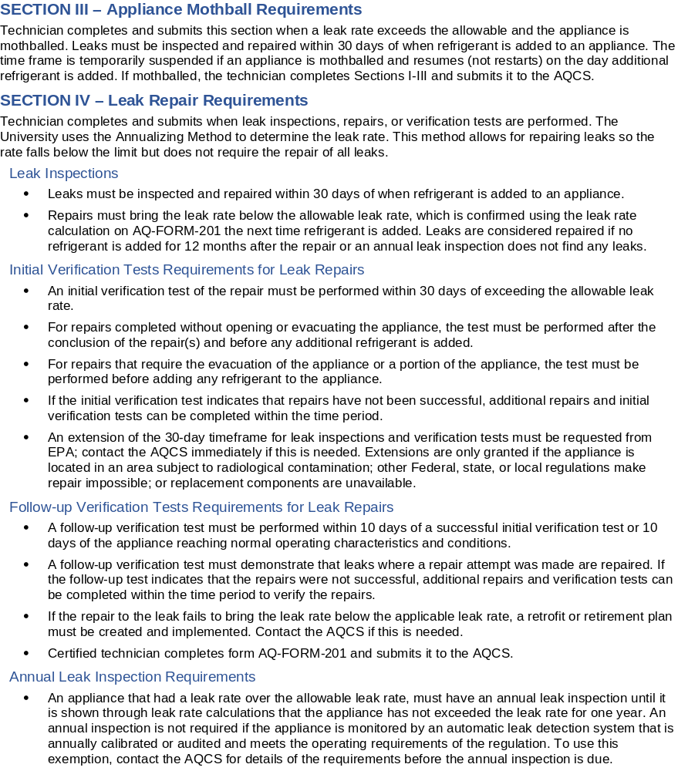
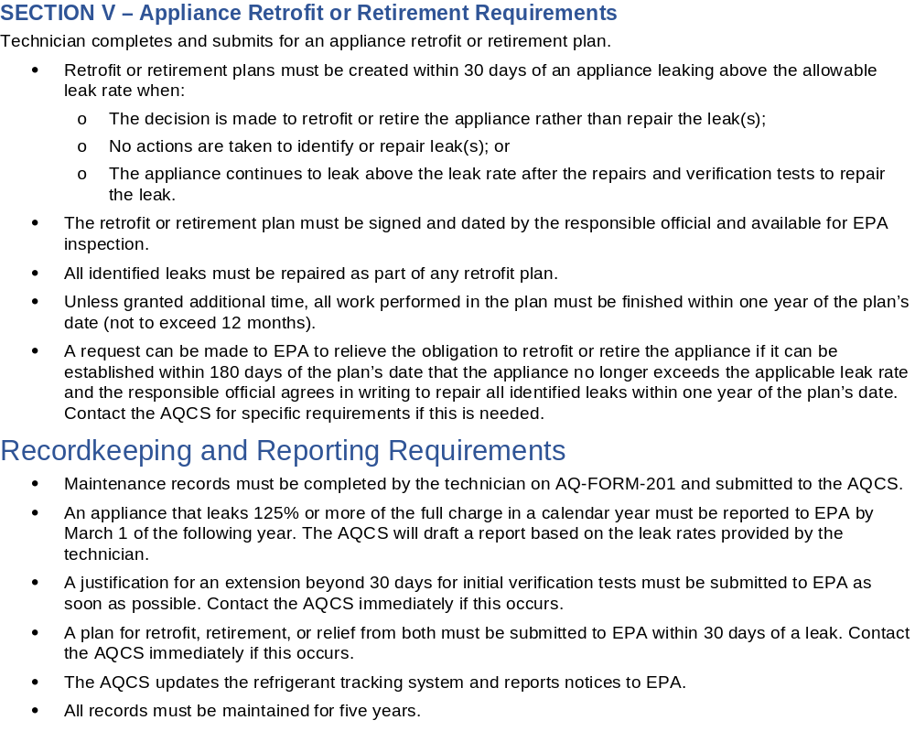

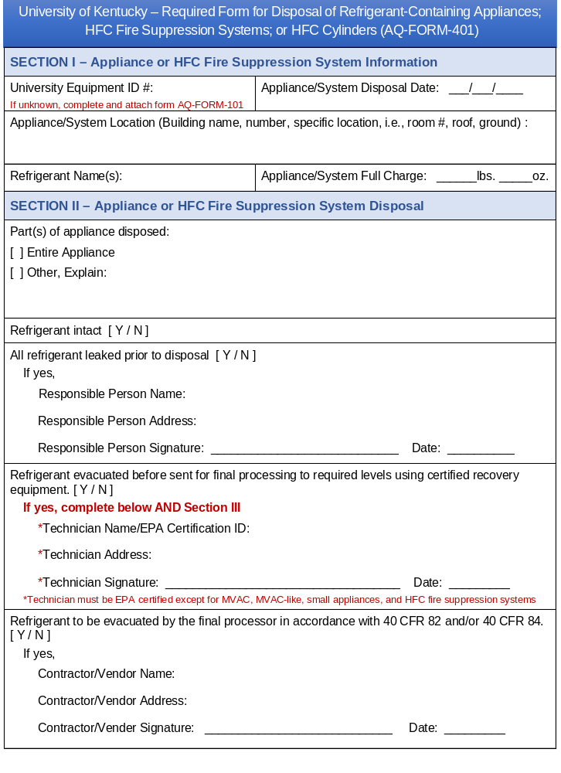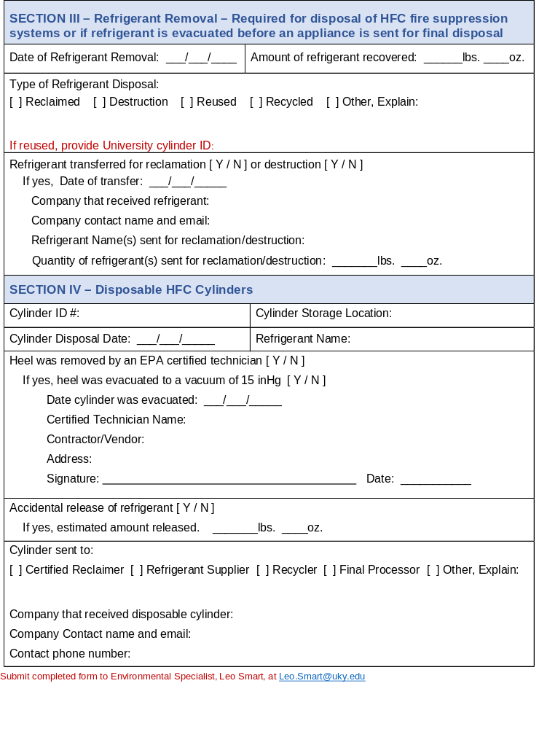
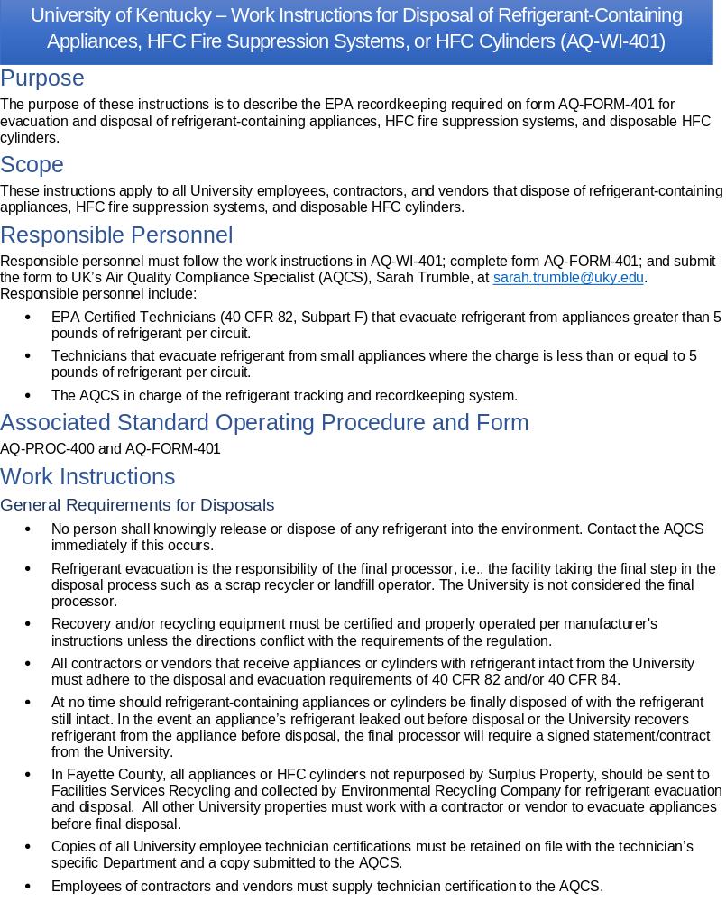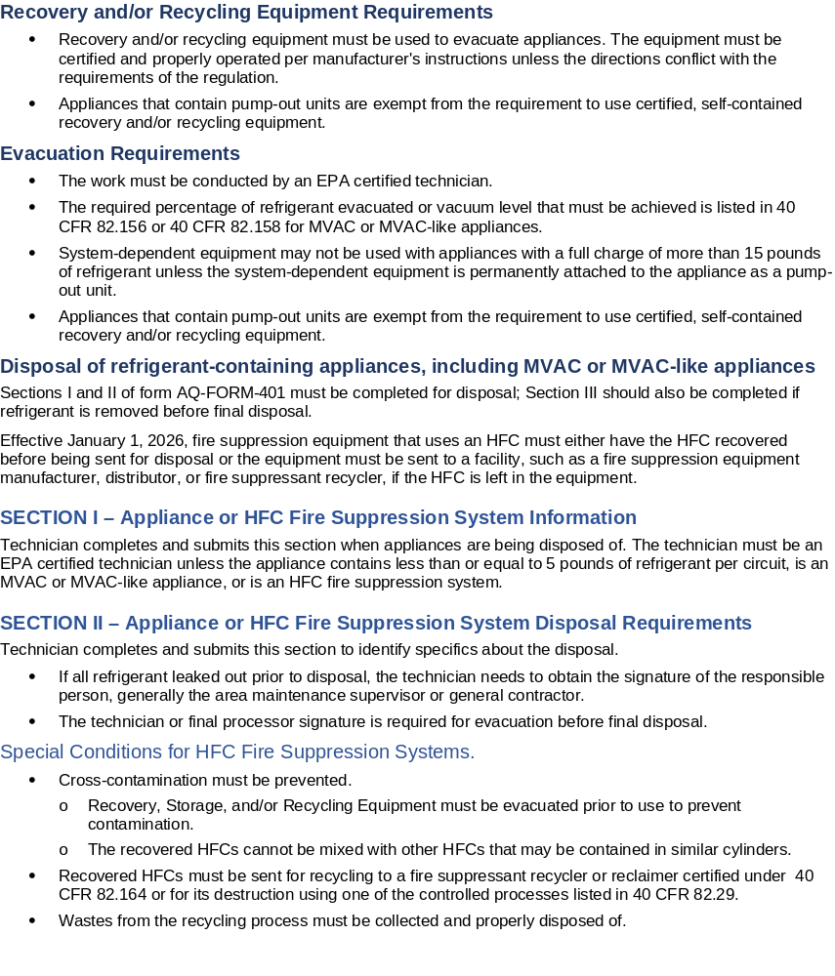
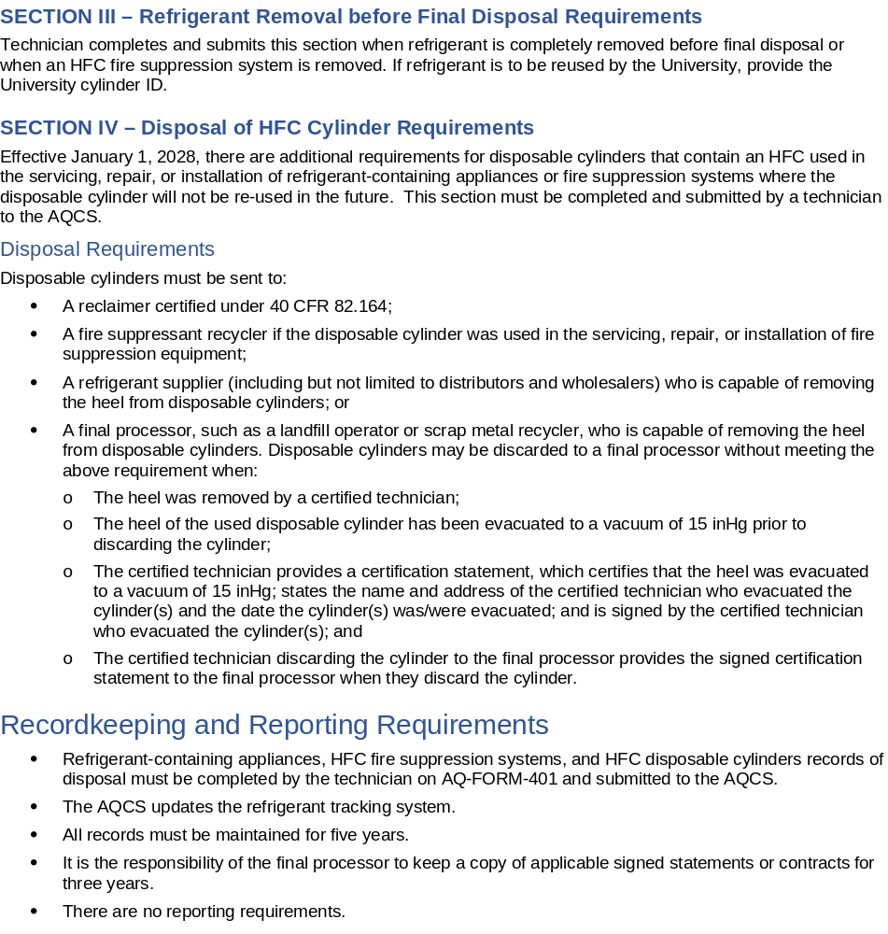
Part 4 WHERE TO SEND FORMS
UK Environmental Management Dept.
Leo Smart, Environmental Specialist
Leo.Smart @uky.edu
901 Journal Avenue
Lexington, KY 40506

REVISION DATE | PAGES | REMARKS
October 2025 | ALL | Updated process and record-keeping requirements
September 2026 | ALL | Updated EQM contact information

