This document has been reformatted to meet current ADA digital accessibility requirements.

210500S01 | Common Work Results for Fire Suppression

- Fire hydrants are to be a separate tap off a looped water main 8” or greater.

- Fire service for a building shall be a separate tap off a looped water main and contain a Post Indicator Valve (PIV)

- Domestic water service may be tapped off a fire service line, only between the main line and the Post Indicator Valve (PIV).

- Provide backflow protection for sprinkler systems.

- The purpose of a fire department connection is to supplement the supply of water to a sprinkler system during an actual fire or to provide a means of suppression when maintenance is being done to the sprinkle alarm valve. Reference is made to the 2013 Edition of NFPA 13, Annex A - – section A.8.817.2.4.4, figures A.8.817.2.4.4(a) and A.8.817.2.4.4(b) for the desired arrangement of the fire department connection.

- Provide freeze protection where the system is subject to freezing by either a dry pipe system or dry pendant heads.

- All piping for the fire suppression system is to be hard piped metal.

- Flexible sprinkler drops are permitted in suspended ceiling systems where field adjustment is required for alignment. Their use shall be limited to applications with accessible ceilings.

Any flexible drop must match hydraulic capacity of the hard-piped system, be braided stainless steel hose type and be UL Listed and FM Approved.

- Provide standpipes with 2-1/2 inch connections in a labeled cabinet with a glass breakout panel. Do not provide a 1-1/2 inch connection or fire hose.

- Do not allow the water flow in the sprinkler pipes to exceed 32 Ft/sec at any point.

- Provide an inspection test station at the furthest point on each zone. Plumb all test station discharge to building drain system.

- Do not use automatic reset or self-closing sprinkler heads.

- All newly installed sprinkler systems must be flow tested by the contractor in the presence of the Consultant’s Engineer, University Project Manager and the University Fire Marshal.

- Do not use concealed sprinkler heads, use semi-recessed sprinkler heads.

- Sprinkler heads are to be centered in ceiling tiles where possible. Deviation from this must be approved by the Consultant’s Engineer and UK Project Manager.

- Provide guards where sprinkler heads are located in mechanical spaces, in workshops, in athletic spaces, below eight (8) Ft. AFF or where the heads may be subject to damage.

- Provide labeling complying with LC-PPD Standard 220553 – Identification for Fire-Suppression Piping and Equipment

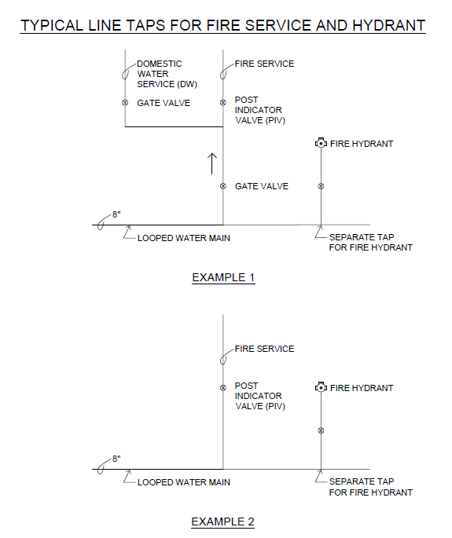

REVISION DATE | PAGES | REMARKS
12/2025 | ALL | General Update
4/2026 | 1 | Revised to permit flexible sprinkler drops in suspended ceilings as a standard installation.
4/2026 | ALL | Verified document meets ADA Digital Accessibility Requirements

